4.3.3 Particle model and pressure – Year 9 Physics Self Study
Facts
- The molecules of a gas are in constant random motion with a range of speeds. This is explained by the Brownian motion.
- The temperature of the gas is related to the average kinetic energy of the molecules
- The pressure in a gas is caused by the constant collision of gas particles on a surface
- The pressure produces a net force at right angles to the wall of the gas container
- The pressure in a gas can be increased by increasing the temperature or by increasing the number of gas particles.
- For a fixed mass of gas held at a constant temperature:
Pressure (in Pa) × volume (in m³) = constant
p V = constant
- The above equation shows us that volume is inversely proportional to pressure.
- Work is the transfer of energy by a force. Doing work on a gas increases the internal energy of the gas
- This causes an increase in the temperature of the gas.

Task 1: Watch free Science lessons and/or visit BBC Bitesize (https://www.bbc.co.uk/bitesize/guides/zqrqh39/revision/1) and do a mind map for the following subtopics
- GCSE Science Physics (9-1) – Particle motion in gases
- GCSE Science Physics (9-1) – Pressure in gases

Task 2: Answer these Questions using the facts above:
- Describe how gas molecules move inside a balloon.
- What will change if the average kinetic energy of the molecules in a gas is changed?
- How is gas pressure caused?
- How can the pressure inside a gas be decreased?
- What is the equation that can be used to find the pressure of a gas after it is compressed, IF the initial pressure and volume of the gas is known?
- What is the internal energy of a gas? How can it be calculated? (Hint: use the facts from the study pack 4.3.2)
- How can the internal energy of a gas be increased?

Task 3: Complete the following calculations
- (a) A balloon is held by a diver. Above the water, the pressure is 1.0 × 10⁵ Pa. The balloon has a volume of 0.025 m³. Calculate the value of the p × V constant for the balloon.
(b)The diver dives underwater with the balloon. At a depth of 25 m, the pressure was 3.5 × 10⁵ Pa. Calculate the volume of the ball at this depth. (Hint: use the above answer for the value of the constant)
(c) If the gas in this balloon has a mass of 0.032kg, calculate the density of the gas when it is above the water.
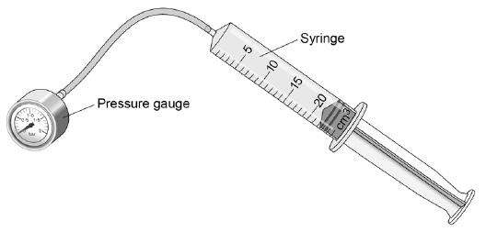
Task 4: Experimental investigation

A student investigated how the pressure of a gas varied with the volume of the gas. The mass and temperature of the gas were constant. The diagram shows the equipment the student used.

Explain, in terms of gas particles, why the pressure in the gas increases as the gas is compressed (4 marks)

Sketch the shape of the graph you would obtain, if you plot the pressure inside the syringe against the volume of the gas

Task 5: Extended answer question
According to kinetic theory, all matter is made up of small particles. The particles are constantly moving. The diagram below shows how the particles may be arranged in a solid.

(a) One kilogram of a gas has a much larger volume than one kilogram of a solid. Use kinetic theory to explain why. (4 marks)

(b) The diagram below shows the particles in a liquid. The liquid is evaporating.

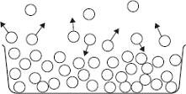

(i) How can you tell from the diagram that the liquid is evaporating? (1 mark)

(ii) The temperature of the liquid in the container decreases as the liquid evaporates. Use the kinetic theory to explain why. (3 marks)

Task 6: Extended writing with research
Research and write about how the air pressure is linked with the volume of the lungs and how this affects the ability to breathe.

