P8.5 Sound
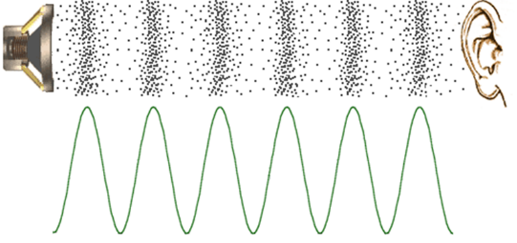
- Sound is a form of energy transfer that travels as longitudinal pressure waves (vibrations).
Low pressure
High pressure
- The regions of high pressure are called compressions, and the areas of low pressure are called rarefactions. The distance from one compression to the next is one wavelength
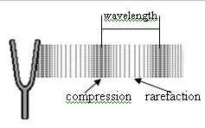
- Sound must have a medium to travel through. Vibrations cannot be transmitted in a vacuum.
- The speed of the wave depends on the density of the media. Sound travels fastest through denser materials because the particles are closer together.
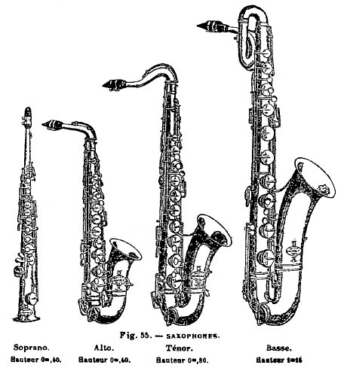
- The speed of the vibration of an object is known as it’s frequency. Something that vibrates very fast has a high frequency and a high pitch (treble). Slower vibrations have a lower frequency and a lower pitch (bass). Smaller things vibrate faster as they have less particles to move
- Frequency is measured in Hertz (Hz). 1 Hertz = 1 full vibration (wavelength) per second
- The difference in pressure between high and low pressure regions is called amplitude. (This is not related to frequency, which is how quickly the sound changes from high to low pressure)
Rapid vibration Slow vibration
High pitch low pitch
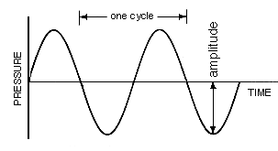
- The larger the amplitude the louder the sound.
- Sound waves are often shown on graphs of pressure (or particle displacement) against time. The taller the curve, the bigger the amplitude and the louder the sound. The closer the peaks the higher the frequency and the higher the pitch
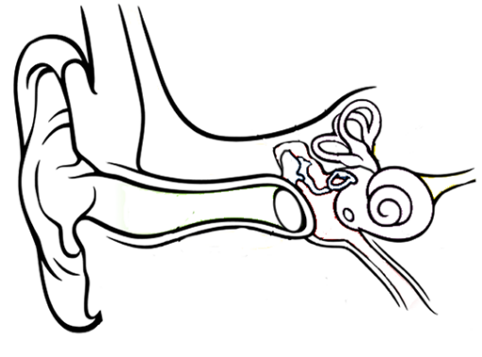
- Human ears contain a membrane called the ear drum which vibrates when the air vibrates. These vibrations pass through the ear bones into the inner ear where they stimulate nerve cells, which send signals to the brain.
Ear bones (ossciles)
cochlea
- Humans can only hear sounds with a frequency between 20 Hz and 20,000Hz. Anything less is known as infrasound and anything greater is known as ultrasound.
Ear lobe (Pinna)
Auditory nerve
Ear drum
Ear canal
- Sufficiently loud noises can damage the ear drum, leading to deafness.
- Some animals use ultrasound to “see” e.g. bats and dolphins
- Humans use ultrasound for prenatal scanning (safer than X-rays) and cleaning
Task 1: Copy and Complete
Like all waves, sound waves may be absorbed, reflected or ___________. When a sound wave is ___________ we call it an echo. We detect sound waves with our ___________. Humans can detect a range of notes with frequencies between _____Hz and _______Hz. Loud sounds have large ___________. Very loud sounds can damage your ___________ leading to hearing loss. Some animals use ultrasound to detect their environment without light. Ultrasound refers to sounds with a ___________ greater than 20,000Hz.

Task 2: Answer these questions
- What sort of wave does sound travel in?
- Why can’t sound travel in space?
- What is the difference between frequency and amplitude?
- What part of a guitar vibrates to make sound?
- What are the frequency limits of human hearing?
- What is ultrasound, and what is it used for?

Task 3: Use the fact sheets to write a table to summarise any key words in bold.

Task 4: BBC Bitesize Video & mind map
Use the link below to go through the information on sound.

https://www.bbc.co.uk/bitesize/topics/zw982hv/articles/z8mmb82

Make a mind map about “sound”.

Task 4: Identify the sounds from their wave form

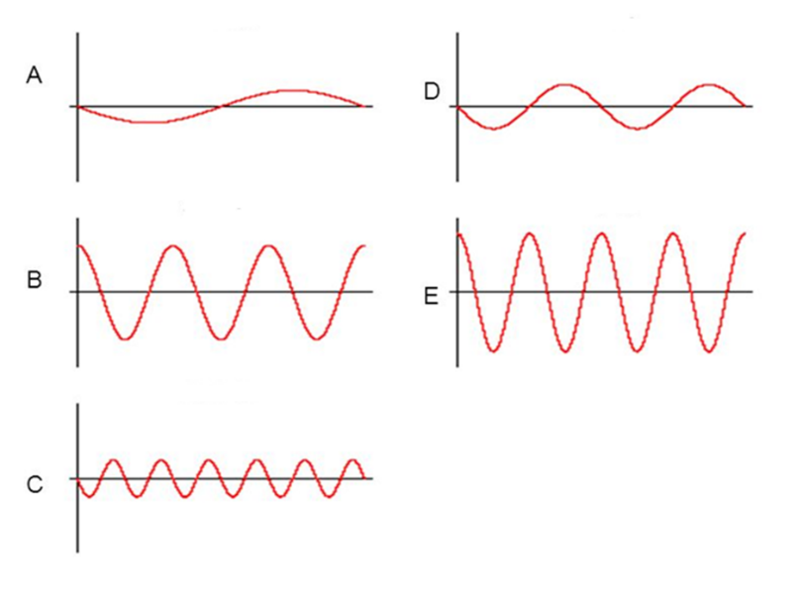
Sketch a sound wave graph and label the axes.
Identify the:
  - Loudest
  - Highest pitch
  - Quietest
  - Lowest pitch

Task 5: Detecting noisy students
Look at this diagram and describe all the ways that the teacher in the corridor can hear the students in the classroom.

Consider transmission and reflection (echoes).

Task 6:
The speed of sound depends on the material it travels through. Draw lines to match the values for the speed of sound with the material.

Material |  | Speed (m/s)
Dry air at ground level |  | 12,000
Seawater |  | 3,240
Diamond |  | 1,533
Gold |  | 972
Helium |  | 343

Task 7: The Ear

Watch the two videos about hearing. You may want to have a look for others too.

- https://youtu.be/mptjEoHF2aI

- https://youtu.be/LkGOGzpbrCk

Draw a diagram of the ear’s structure and label it.

Write a list of the functions of different parts of the ear.

Task 8: What am I
- This is the number of waves each second
- A _____ sound has a high frequency
- This is a way of describing the height of the sound waves
- This is the distance from one sound wave to the next
- Sound travels quickest through these materials
- This is another word for the loudness of a sound
- These movements produce sound
- This is a way of describing how high/low a note is
- This is the unit for measuring the number of waves per second.
Task 9: Finding the speed of sound pt1

To find the speed of something you only need to know the time taken to travel a known distance. Look at the pictures below and describe an experiment to find the speed of sound.
Detail the variables, what you would measure and how, and what calculations you would need to find your answer. Consider how you would get the most accurate measurement.
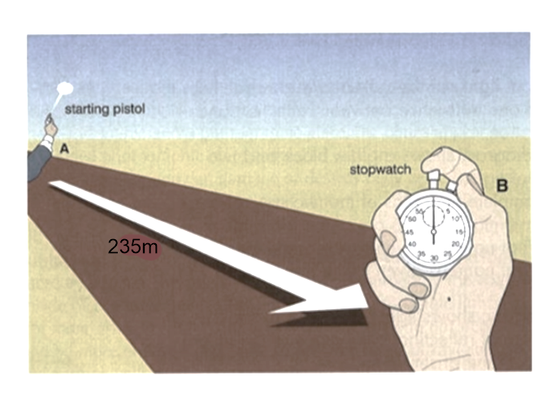

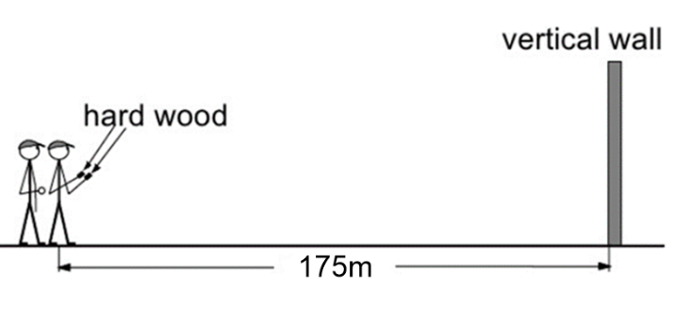

Task 10: Finding the speed of sound pt2

Watch Mark Rober’s video World’s Largest Horn Shatters Glass

https://youtu.be/pFEB0chiuJA

Explain how he was able to find the speed of sound.

- Include details such as how he was able to hear the sound from a long way away.

- How accurate do you think his measurement was?

- What might have affected how accurate he could be?

Mark Rober also breaks some glass in his video. Explain how he does this without touching the glass.

