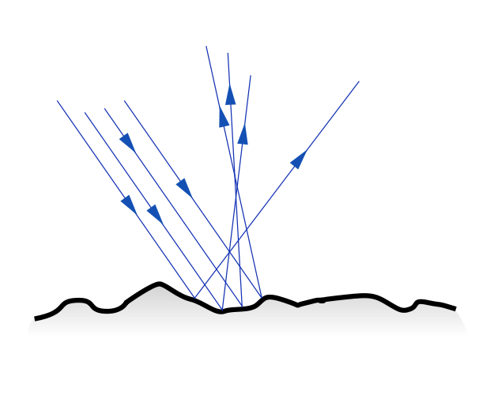
P8.4 Light
- Light is form of energy transfer that travels as a (transverse) wave
Diffuse reflection
- Light is emitted from very hot objects (fire and light bulbs) or fluorescent tubes
- Light may be detected by specialised cells in the eye
- Light always travels in a straight line at 300 million metres per second (in air)
- Light spreads out from its source in all directions unless blocked
Specular reflection
- Like all waves light can be:
  - Absorbed
  - Reflected
  - Transmitted
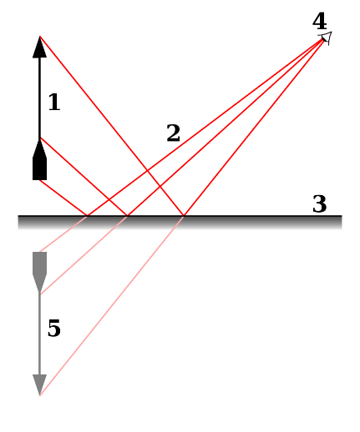
- Light can be reflected either irregularly (diffuse) when light is scattered in all directions from the surface
- Or light can be reflected evenly (specular) when the surface reflecting it is perfectly flat
- Specular reflection is commonly seen in shiny objects such as mirrors, and allows the formation of an image
  - The diagram shows the object at 1.
  - The light rays (2) reflect from the mirror (3)
  - And reach the observer at 4
  - However the light appears to come from position 5, so the observer sees a virtual image
  - Virtual images are reversed left to right, but not vertically
- The law of reflection states that the light of an incident ray is reflected at the same angle measured from the normal
(The normal is always at 90 to the surface of the mirror)
angle of incidence = angle of reflection
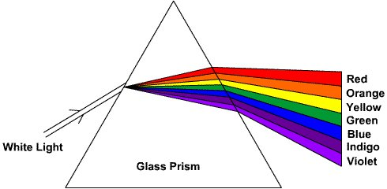
- Light is transmitted by a lens which bends the light ray through a process called refraction.
- Refraction happens because the light slows down in denser materials such as glass or water
- Refraction also causes white light to disperse and form a spectrum.
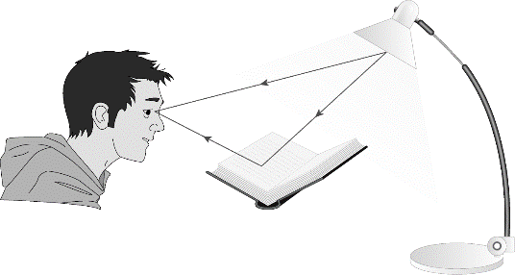
- Dispersion happens because white light is a mixture of all other colours, and different colours slow down and bend different amounts

Task 1: Copy and Complete
Light reflecting from a sheet of paper is called __________ reflection. It reflects in ___________ directions. Shiny surfaces like a mirror _________ light. Light reflecting from a mirror is called _________ reflection. It reflects in the ________ direction.

Task 2: Answer these questions
- What sort of wave does light travel in?
- How does light travel?
- How fast does light travel?
- What does light scattering mean?
- What is specular reflection?
- What is the law of reflection?
- What is refraction?
- What is the spectrum?

Task 3: Use the fact sheets to write a table to summarise any key words in bold.

Task 4: BBC Bitesize Video & mind map
Use the link below to go through the information on light.

https://www.bbc.co.uk/bitesize/guides/zq7thyc/revision/1

Make a mind map about “light”.

Task 4: Copy and complete the diagram
Use coloured pens or pencils to show what happens to white light when it enters a prism. In the box on the right write a description of what happens. You should include the key words provided.
white light colours prism spectrum dispersion

Task 5:
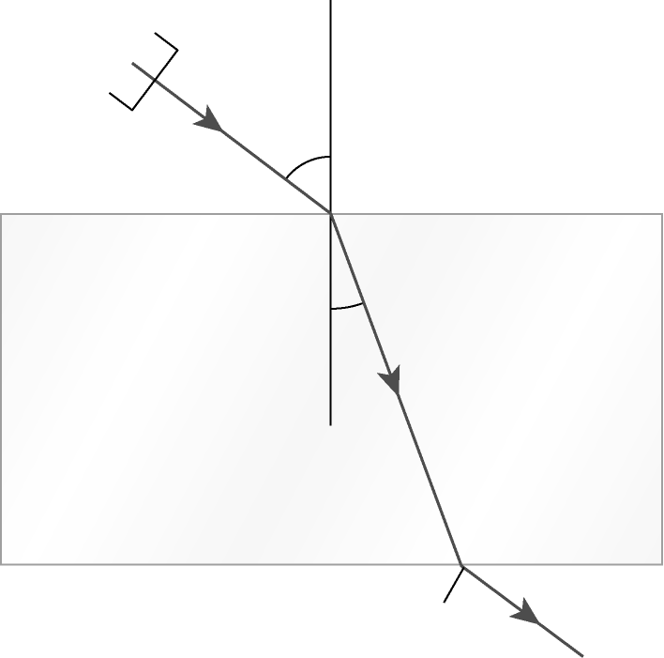
Look at this diagram of light moving through a glass block.
Understanding this diagram can help you explain what happens when light is refracted.
Write an explanation for the refraction of light. Make sure you include these key words. lights travels glass block direction bend because normal

Task 6:
Use these numbers to complete the sentences. 20 90 300
Joe shone light at a flat mirror. He measured angles from the normal. The normal is at ____ degrees to the mirror’s surface. The angle of the incident ray was 20 degrees. The angle of the reflected ray was ____ degrees.This obeyed the law of reflection. The speed of light is ____ million m/s.

Task 7: Copy and Complete these sentences
- Light cannot travel through opaque objects…
- Light travels in straight lines…
- Most objects reflect light…
- The surface of a mirror is very smooth…
- The normal is a line at 90˚ to the mirror
- Rough surfaces reflect light…
- We can show what happens in mirrors using ray diagrams…
- We can see images in mirrors…
Task 8: The Eye
Watch the two videos about the eye. You may want to have a look for others too.
- https://www.bbc.co.uk/bitesize/clips/zf9c87h
- http://www.bbc.co.uk/education/clips/z97qxnb
Draw a diagram of the eye’s structure and label it.
Write a list of the functions of different parts of the eye.

Task 9: What am I?
Decide what key word these statements are referring to.
- Something that gives off its own light
- The equipment we use to make lines of light
- Something that travels at 300,000,000 m/s
- This is the name for a flat mirror
- The angle between the light ray and the normal line
- A simple type of camera
- An object that lets some light through and glows
- When light is scattered in all directions, it is known as this type of reflection

Extension: make your own “what am I’s” for a selection of key words, try and make them as challenging as possible.

Task 10: Research
Research how we can experiment with light to observe reflection and refraction.
Make detailed plans of how you would carry out these experiments.

