Keyword | Definition
Rock cycle | Sequence of processes where rocks change from one type to another.
Weathering | The wearing down of rock by physical, chemical or biological processes.
Erosion | Movement of rock by water, ice or wind (transportation)
Minerals | Chemicals that rocks are made from.
Sedimentary rocks | Formed from layers of sediment, and which can contain fossils.  Examples are limestone, chalk and sandstone.
Igneous rocks | Formed from cooled magma, with minerals arranged in crystals. Examples are granite, basalt and obsidian.
Metamorphic rock | Formed from existing rocks exposed to heat and pressure over a long time. Examples are marble, slate and schist.
Strata | Layers of sedimentary rock.
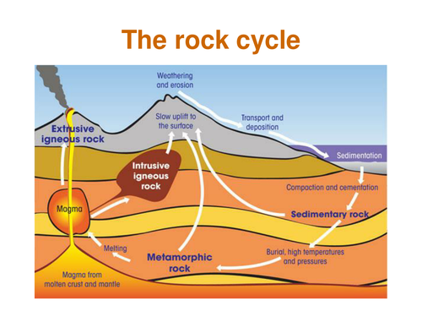
C7.4 The Earth`s Structure

Key Knowledge
The three types of rock are sedimentary, igneous and metamorphic rock.
Sedimentary, igneous and metamorphic rocks can be changed between each type over millions of years through weathering and erosion, heat and pressure, and melting and cooling
The three different types of weathering are; physical, chemical and biological weathering.
The rock cycle is the term used to describe the physical and chemical changes that occur when one type of rock is changed into another.
Different types of igneous, sedimentary and metamorphic rock can be made, depending on the conditions in which they are made.

Useful links: https://www.bbc.co.uk/bitesize/guides/zwd2mp3/revision/2
https://www.youtube.com/watch?v=EGK1KkLjdQY
https://www.youtube.com/watch?v=53lMdHzvGCQ
https://www.youtube.com/watch?v=CeuYx-AbZdo
Task: Copy and complete these
Metamorphic rocks
All rocks are made of different ______________. When these minerals are _________ and squashed, they can change into _____________ ones. Metamorphic rocks have been __________ within the Earth.
All ___________ rocks were originally other types of rocks. As more layers of rocks built up, the older rocks get pushed _________ into the Earth. Gradually, over a very ________ period, the rocks get changed into _____________ rocks. One example is the ______________ rock limestone, which changes into _____________ when it is heated and squashed.
Keywords: Metamorphic, down, minerals, different, heated, changed, long, sedimentary

Igneous rocks
Igneous rocks are formed when liquid hot rock (___________) comes up towards the surface. As it rises it __________ and ______________, either above the surface or ________ the surface.
We call igneous rocks which form above the surface: ____________ igneous rocks and we call igneous rocks which form below the surface: _____________ igneous rocks. Both these rocks have different _____________ due to the speed at which they have ___________.
Keywords: Cooled, extrusive, magma, crystallises, intrusive, cools, below, features.

Sedimentary rocks
A river carries, or ___________ pieces of broken rocks as it flows along. When the river reaches a lake or the sea, its load of transported rock settles at the bottom. We say that the rocks are _________. This process is known as _________. The rocks build up in layers called ____________. This process is called _________________.
The weight of the sediments on _____ squashes the sediment at the ________. This is known as ____________. The water is squeezed out from between the pieces of rock and __________ of different salts form. These crystals stick the pieces of rock together. This process is called ________________.
This process eventually makes sedimentary rocks. It may take ________ of years for this type of rock to form. Sedimentary rocks may contain _________.
Keywords: Cementation, Deposition, Sedimentation, Compaction, Million, Top, Fossil, Bottom, Sediments, Transports, Deposited, Crystals
Task: Answer the following questions.
- State the three types of rock.
- Magma and lava are both molten (melted) rock. What is the difference between them?
- What is the name of the process that wears away existing rock?
- Each rock type has different features. Tick the correct column for each feature to show which rock type it refers to.

Type of rock
Formed from sediment that is squashed
Formed from lava or magma
Formed by the action of heat and pressure on existing rocks
Sometimes contain fossils
Type of rock usually found near the surface
Often found in volcanic areas
Crystals can often be seen in the rock

- Igneous rocks can form both outside and inside volcanic mountains. The size of the crystals in them varies. Select the best word to complete each sentence.
- Molten rock that cools outside a volcano forms large/small crystals.
- Molten rock that cools inside a volcano forms large/small crystals.
- Molten rock that cools outside a volcano will cool slowly/quickly.
- Molten rock that cools inside a volcano will cool slowly/quickly.
- In conclusion, the slower the rate of cooling, the larger/smaller the crystals.

- *Granite is a rock with large crystals, whereas basalt is a rock with small crystals. Suggest how they are formed.
- Why would you not expect to find fossils in metamorphic and igneous rocks?
- * Describe how weathering can eventually produce igneous rock in the rock cycle.
True or False? Use the links provided and other sources to help you complete the following tasks
- Metamorphic rocks can undergo melting to become igneous rocks.
- Sedimentary rocks may be porous.
- Radioactive decay in the inner core creates all the heat deep inside the Earth.
- Sediments undergo erosion, transportation and burial before becoming sedimentary rocks.
- Lithification is the processes of lava cooling and solidifying to become igneous rock.
- Limestone can be metamorphosed to marble.
- Basalt is an igneous rock.
- Examples of sedimentary rocks include sandstone, limestone, chalk and clay.
- The rock cycle never stops.
- Freeze-thaw is a form of physical weathering in the rock cycle.

Tasks:
- Create a cartoon strip of how your adventures in the rock cycle occurred (12 boxes). Each drawing should be labelled/with appropriate descriptions.
OR
Write a creative story about a rock that goes through the rock cycle, perhaps even pretending to be the rock itself. (The story should explain what experiences the rock undergoes to turn from one rock into another and MUST include diagrams.)
ALL
- Describe similarities and differences between the rock cycle and everyday physical and chemical processes.

