B7.5 - The skeleton
There are 206 bones in our skeleton.
Bone is a living tissue, made of calcium carbonate crystals.
Some examples of bones found in our body are:
Skull (cranium), ribs, femur, ulna, radius, patella, humerus, fibula, tibia, spine
The functions of the skeleton:
- Support for the body
- Protection of major organs
- To allow movement
- To produce new red blood cells in the bone marrow.
Joints:
The skeleton is made of bones, which meet at joints.
Synovial joints are made up of:
- Cartilage: this covers bones and prevents friction
- Ligament: this connects bones to other bones
- Tendon: this connects bone to muscle
- Synovial fluid: this reduces friction and prevents against jolts, it helps with movement
- Synovial membrane: this keeps synovial fluid in place
There are different types of joints to allow different kinds of movement:
- Ball and socket joints (e.g. shoulder, hip) allow movement in different directions
- Hinge joint (e.g. shoulder) – movement occurs up and down
- Fused joints (e.g. spine) – only small amounts of movement can occur
- Fixed joints (e.g. skull) – no movement because the joints have fused together
- Gliding joint (e.g. foot) - bones slide over each other
- Pivot joints – this allows the head to turn

Task 1
- What are bones made up from?
- What is the Function of the Skeleton?
- Synovial joints are made up of several different things. List 3 and their properties.
- Draw a table of the different types of joints and what different kind of movement they allow.

Muscles:
- Muscles are made of muscle cells.
- Muscles have lots of mitochondria to release energy for movement.
- Muscles become shorter and fatter when they contract.
- When muscles relax they become longer and thinner.
- There are different types of muscles:
- Cardiac –found in the heart
- Smooth (involuntary) – found in the digestive system,
- Voluntary (skeletal) – found attached to bones in the skeleton

Muscles can be found in pairs called antagonistic pairs
Examples are the biceps and triceps:
- When we move our forearm up, the biceps contract and the triceps relax.
- When we move our forearm down, the opposite happens. The triceps contact and the biceps relax.

Muscles generate a force when they contract, which can be measure in Newtons (N).
Muscles are attached to nerves which receive electrical signals to tell them to contract.
Factors that affect muscle strength include:
- The size of the muscle
- The size and strength of the electrical signal from the nerves
- The mechanical strength of the bones and joints

Task 2
- Why do Muscle cells have lots of mitochondria?
- What happens to Muscles when they Contract and Relax?
- What are the 3 different types of Muscles listed above and how do they differ?
- What does antagonistic pair mean?
- One example of an antagonistic pair are the biceps and Triceps research and construct a table of 5 different antagonistic pairs of muscles including what happens when one contracts and relaxes.

The shape you’re in
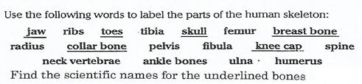
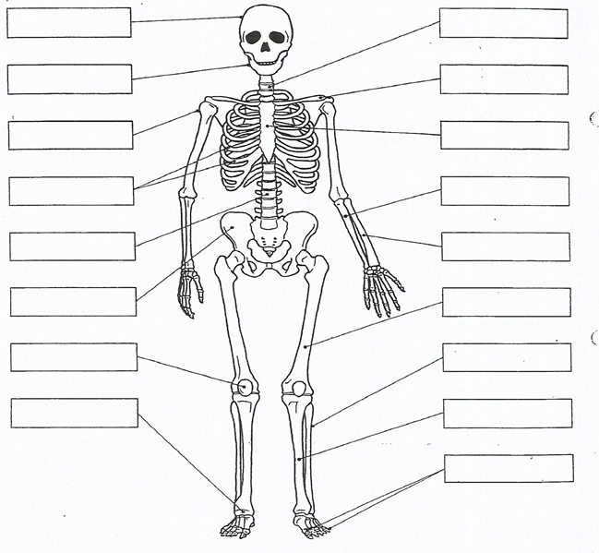
Sketch and complete the diagram into your books.

Task 3: Table
Make a table for the following key words and write their definitions.
Vertebrate, Skeleton, antagonistic pair, ligament, tendon, support, movement

Task 4: Mind map
Complete a revision mind map on the topic on A4 paper, including all the keywords.

Task 5: Research Task: How do you repair a broken bones, do all broken bones require surgery?

Task 6: Mark Scheme
- Design a 5 mark exam question on the topic and write a mark scheme.

Task 7: Research Task
What happens to your body muscles during a run?

Task 8: Further Questions
- What do the tendon connect? Are they stretchy or stiff?
- What would happen if tendons were stretchy?
- Why do tendons have to be tough?
- What type of tissue is cartilage made out of?
- Where on bones does cartilage form?
- What happens when someone has arthritis?
- What do the ligaments connect? Are they stretchy or stiff?
- What would happen if ligaments were stiff?
- Where would you find the Synovial fluid?
- What does the Synovial fluid do for the joint?
- Why is it important during exercise?

