B 7.4 Interdependence
- A food chain shows what an organism eats this could be a plant or another animal. It is presented in a line going from left to right with arrows showing how an organism feeds.
- A food web show many food chains that interlink for a given habitat of animals and plants.
- A food web is presented with the plants at the bottom and the feeding levels moving upwards with the top predator at the top of the page. The arrows show what the organisms eat.
- A food web can be altered by pollution or a link in the food chain being affected by one organism that can have an effect on the numbers of the organisms in the rest of the food web. This results in the numbers of other organisms that are connected either increasing or decreasing.
- A pesticide is a chemical that will kill an organism. This organism can be an insect (has 6 legs) which feeds on a plant.
- Pesticides can seriously damage food chains and cause the death of a given feeding level in the food chain.
- The toxic chemical or pesticide can pass up through a food chain in the animal’s body, getting more and more concentrated as it reaches the top predator. This build up is known as Bioaccumulation.
- Animals and plants need Resources in order to live, if these resources are missing the numbers will go down or if they are limited (e.g. not much space) then the organism will compete for these resources.
- Competition is when organisms complete (fight) for resources.
- Most animals compete for food, space, oxygen, shelter, and a mate to breed with.
- Plants compete for light, space to grow, mineral salts and water.
- A predator is an organism that hunts and eats another organism.
- A prey is the organism that is hunted by the predator.
- A graph of the interaction of the predator and prey relationships can be presented to show how the number of the predator and prey can rise or lower depending upon how many prey are being eaten for example.
- This graph is presented as time along the X axis with the numbers of both predator and prey presented on the Y axis.
- The graph usually follows a rise and fall of each animal type as they are hunted or if there is not many organisms to support and feed them.

Task 1:Make a table with these key words and complete the definitions.
Key words: Food Web, Food Chain, Ecosystem, Environment, Population, Producer, Consumer, Decomposer

Task 2: Answer these questions
- What is a food chain?
- What is a food web?
- What can a food web be affected by?
- What do the arrows in a food chain represent?
- What do pesticides do?
- What do organisms compete for?
- What is a predator-prey cycle?
- What is meant by bioaccumulation?

Task 3: Convert the food chains above into a food web

A: rosebush rose aphid hoverfly lava
B: peach tree peach-potato aphid swallow sparrowhawk
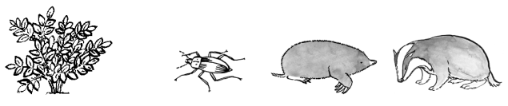
C: potato plant beetle mole badger
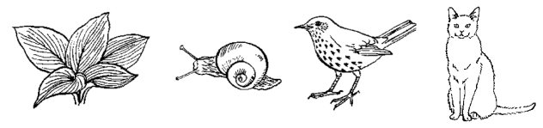
D: hosta snail thrush cat
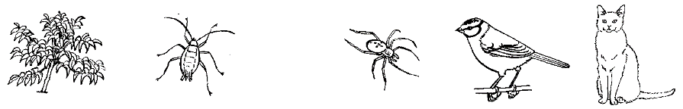
E: peach tree peach-potato aphid spider blue tit cat
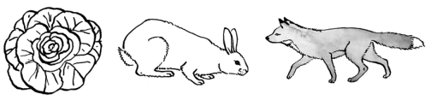
F: lettuce rabbit fox
G: lettuce peach-potato aphid hoverfly lava blue tit sparrowhawk

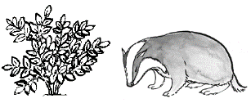
H: potato plant badger
Task 4: Use the graph to answer the questions below.

Look at this graph. It has two vertical axes, one for the rabbits and one for the foxes. It shows how the populations of foxes and rabbits have changed in one area. Each population was measured at the middle of every year.

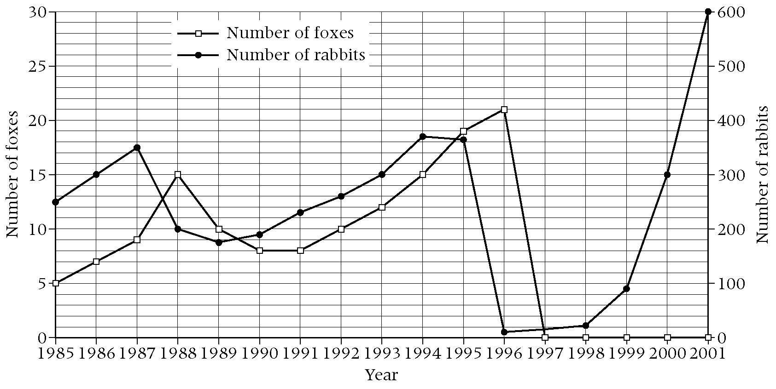

a Which animal is the predator?

b Which animal is the prey?

c How many rabbits were there in 1989?

d How many foxes were there in 1993?

e In which year were there the most foxes?

f Explain why the number of foxes fell between 1988 and 1990.

g During 1996 the rabbit population was almost totally wiped out. Give one possible reason for this.

h In 1997 there were no foxes. Give one reason for this.

Task 5: Pesticide Research
Research and complete a table stating the advantages and disadvantages of using pesticides.
Make a table to summarise these advantages and disadvantages.
Complete an evaluation of at least 300 words stating your opinion on pesticides and if they should be used by farmers.

Task 5: Letter to Mr Carney
Using all the information, write a letter to Mr Carney on the topic of pesticides. You
Ensure it is correctly formatted.

Task 6: Mind Map
Complete an A4 mind map on this topic, can you think of any links to the adaptation module?
- Write a 500 word essay summarising the whole topic, using each of the key words mentioned above.

