Year 10 Physics – Forces 2
Resultant forces (P4.5.1.4)
- The resultant force is the one single force which has the same effect as a number of different forces acting at a point.
- Free body diagrams show all the forces acting on an object
- A single force can be split into two components at right angles to each other
- A body in equilibrium has no resultant force acting on it.
Forces and elasticity (P4.5.3)
- More than one force is needed to bend, stretch or squash an object
- Force is a vector quantity
- Force is measured in newtons (N)
- Elastic materials return to their original shape when the force is removed from them.
- Inelastic (plastic) materials stay stretched, squashed or bent when the force is removed from them
- The extension of an object is how much it has stretched by.
- The extension of an elastic object (eg a spring) is directly proportional to the force applied to it as long as the limit of proportionality is not exceeded
- Force = spring constant x extension F = k x e (e is the extension or the compression)
- The spring constant k has units of N/m or N/cm
- A stretched or compressed spring stores elastic potential energy
- Elastic potential energy = 0.5 x spring constant x (extension)²
- Elastic potential energy has units of joules (J)

Tasks / questions
- Write down the unit of force
- Write down the unit of mass
- Name 2 non contact forces.
- Name 3 contact forces.
- Write down 4 vector quantities.
- Write down 5 scalar quantities.
- Now watch and make careful notes on the following youtube clips:
https://www.youtube.com/watch?v=PL8ATKipoB4 - resultant forces
https://www.youtube.com/watch?v=PG8wV022Eu0 – resultants of perpendicular force
- Draw a free body diagram for a helicopter, of weight 2000N, hovering at a constant height.
- Draw a free body diagram for a person standing on one leg on the floor
- Draw a free body diagrams for a duck swimming along a canal
- Draw a free body diagram for a person parachuting from an aircraft, just before the parachute is opened
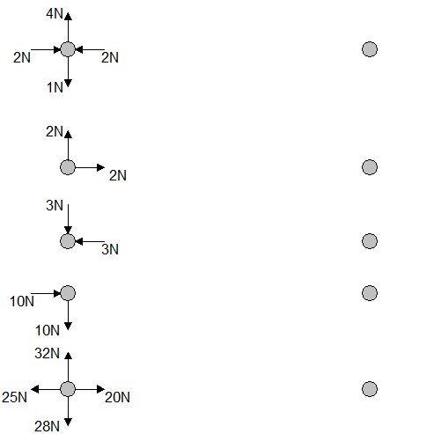
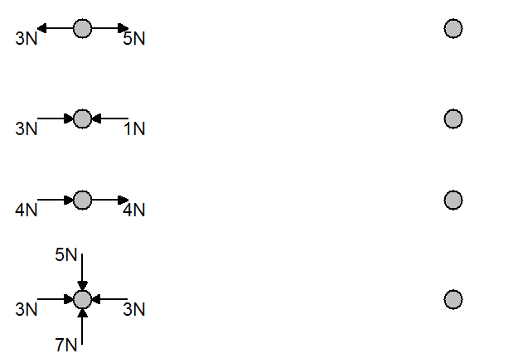
- Draw / Calculate the resultant of these forces:

- Watch the clip and carefully describe and explain what you see in terms of the forces acting on each object. https://www.youtube.com/watch?v=E43-CfukEgs
- Down load the following simulation which will allow you to carry out an experiment about springs
https://phet.colorado.edu/sims/html/hookes-law/latest/hookes-law_en.html
Tick the ‘applied force’ , ‘displacement’ and ‘values’ boxes and click the icon so that you get 2 springs on the screen
- Set one spring constant to 200N/m and the other to 600N/m. Don’t change these values.
- Draw a table with the following headings, allow enough space for 11 reading of force
100N/m spring |  | 600N/m spring
Force (N) | Displacement (m) | Force (N) | Displacement (m)

For each spring, record the displacement (amount of stretch) for forces of 0, 10, 20 100N
- Using excel or a suitable graph package, or graph paper! Plot graphs of force vs extension for each spring. Draw lines of best fit.
- Write a detailed conclusion – what do your results tell you about how the extension is affected by the force? What is the effect of having a larger spring constant?
- When the force is a negative value, the spring is being squashed. Does it behave the same way when it is squashed. Take and record some data to find out.
- Research what happens to the graph when the force on a spring keeps getting bigger until it breaks. Sketch the graph and add labels to important parts of the graph
- Write down Hookes Law
- Explain what is meant by
a elastic behaviour
b. plastic behaviour
c. limit of proportionality
- The energy stored in the spring (elastic potential energy) = ½ x spring constant x extension²
(the extension is the displacement on the simulation)
Calculate the energy stored in each spring when the force on it is 50N
Extension – If the energy stored was plotted against the force on the spring, what shape would the graph be. Explain your answer carefully and support with reference to the equations
- Watch and summarise https://www.youtube.com/watch?v=ACDbJ8rsQDo
- Watch, make careful notes and diagrams https://www.youtube.com/watch?v=jQAt3e6Bz7U
This is a required practical, so you need to know it!

