4.3.1 Changes of state and the particle model – Year 9 Physics Self Study
Facts
- The three states of matter are solid, liquid and gas
- The different states of matter and the differences in densities can be explained by the particle model
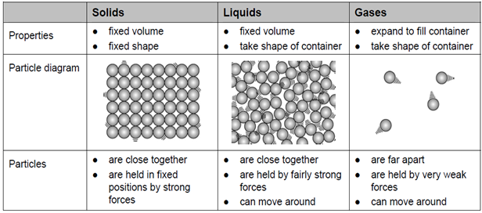
- When substances change state, mass is conserved.
- Change of state is a physical change because the material recovers its original properties if the change is reversed.
- Melting, freezing, boiling, evaporating, condensing and sublimating are different changes of state.
- The density of a material is defined by the equation:
Density = Mass (kg or g)
(kg/m³ or g/cm³) Volume (m³ or cm³)

- When finding the density of an irregular object, its volume can be found by immersing the object completely in a displacement can (The volume of the water displaced = the volume of the object). The mass can be measured using an electronic balance or scales.

Task 1: Watch free Science lessons and/or visit BBC Bitesize (https://www.bbc.co.uk/bitesize/guides/zsqngdm/revision/1) and do a mind map for the following subtopics
- GCSE Science Physics (9-1) Particle model and changes of state
- GCSE Science Physics (9-1) Density and determining the densities of regular and irregular objects

Task 2: Answer these Questions:
- What is density and how is it calculated?
- How can you calculate the volume of a regular object like a cube?
- The length of a wooden cube was 3cm. The mass is 20g. Calculate the density of the cube in g/cm³
- How can you calculate the volume of an irregular object like a stone?
- The volume of the stone was 18.0cm³. The student measured the mass as 48.6g. Calculate the density of the stone in g/cm³
- Draw particle model diagrams for the three states of matter and write their properties
- Explain, in terms of particles, why gases are easy to compress.

Task 3: Write the definitions for melting, freezing, boiling, evaporating, condensing and sublimating. Draw the three states of matter and add arrows in between to show the changes of state. Label the arrows with the correct word from the above definitions.
Mention why change of state is a physical change.

Task 4:
- Rearrange the density equation to calculate the mass of an object.
- If the density of a metal cube is 7.87g/cm³ and the volume is 300cm³ what is its mass?
- Rearrange the density equation to calculate the volume of an object.
- If the density of a gold crown is 19.3g/cm³ and the mass is 500g what is its volume?
- If the density of a steel cube is 7700kg/m³ and the mass is 200kg what is its’ length? (Hint: Find the volume first and think about how the volume is calculated for a cube)
- If the density of a rock is 15g/cm³ and the mass is 0.5kg what is its volume in cm³?

Task 5: Exam Q

A student wants to calculate the density of the two objects shown in the figure below.

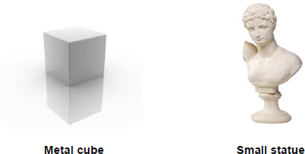

© Whitehoune/iStock/Thinkstock, © Marc Dietrich/Hemera/Thinkstock

Describe the methods that the student should use to calculate the densities of the two objects. (6 marks)

Task 6: Extended writing with research
Research and write down how Archimedes (by using a displacement method), determined whether the goldsmith cheated the king when making the king’s gold crown.

