C9 Chemistry of the Atmosphere Pack For Year 9 and 10 – Part 1
Gases in today's atmosphere
- Approximately 80% of atmosphere is nitrogen
- Approximately 20% of atmosphere is oxygen
- Other gases include; carbon dioxide, water vapour and noble gases
Earths Early Atmosphere
- There are numerous theories as to why the earth’s atmosphere has changed over time however, evidence is difficult to find as events occurred over 4.6 billion years ago.
- One theory: for the first billion years, the earth was covered in volcanoes that released carbon dioxide and water vapour (which ultimately condensed to form the oceans), with little oxygen and small amounts of nitrogen, methane and ammonia.
- Carbon dioxide dissolved in oceans, to form carbonates which precipitated, forming sediment, reducing levels of CO₂.
Oxygen Levels Increased
- Algae and plants photosynthesised, releasing oxygen:

Carbon dioxide + Water Glucose + Oxygen
6CO₂ + 6H₂0 C₆H₁₂O₆ + 6O₂
- Algae first produced oxygen 2.7 billion years ago. Over the next billion years, plants evolved, and oxygen levels increased.
Carbon dioxide levels decreased
- Carbon dioxide levels decreased as the gas was trapped in sedimentary rocks and fossil fuels. Photosynthesis also lead to a reduction in carbon dioxide levels.

Task 1: Watch Free Science lessons (if you can) and do a mind map of the information

GCSE Science Chemistry (9-1) The Atmosphere

GCSE Science Chemistry (9-1) Fossil Fuels

Task 2: Test yourself! Answer these quick fire questions.
Task 3: Fill in the gaps.
Plants and animals need for . If plants did not make in , there would soon be no oxygen left for and all life would die. Plants are important for keeping the in balance. Most ___ on the Earth happens in forests, particularly in tropical _____. Forests occupy only about 33% of the area on the Earth, but they carry out 65% of all . The amount of _______________ in the atmosphere is _______________, and may be leading to _______________ warming. In many countries, _______________ are being cut down and , which adds to the air. It also removes _______________ that could have used up carbon dioxide to produce _______________.

atmosphere biomass burned carbon dioxide decreasing Earth forests global

warming greenhouse in balance increasing land methane oxygen

photosynthesis rainforests respiration sea trees

Task 4: Answer these key word questions.
- a What ‘CD’ is a gas made by burning fossil fuels?
b What ‘M’ is a gas made by cows’ digestive systems?
c What ‘GG’ are gases which can trap heat?
d What ‘GW’ means the Earth may be getting hotter?
e What ‘F’ is where most photosynthesis happens?
Task 5: Complete the crossword.
Fill in the spaces in the sentences below using the words in the box. Check that you have chosen the
right word each time by making sure it fits in the grid underneath. If all the words are correct you
should be able to spell out another word on the grid.
algae bacteria carbon dioxide harmful methane
ozone photosynthesis seas steam volcanoes

1 The first green things that could photosynthesise were one celled ........................ .
2 Early volcanoes gave out large amounts of carbon dioxide and ........................ .
3 The ozone layer keeps out ........................ ultra violet rays.
4 The atmosphere was made when ........................ erupted.
5 When the steam condensed it formed the oceans and ........................ .
6 The green algae made their food by ........................ .
7 The early atmosphere contained small amounts of the gases ammonia and ........................ .
8 The ........................ layer keeps out harmful ultraviolet rays.
9 The green algae use up ........................ ........................ in photosynthesis.
10 The first living things on Earth were simple ........................ .

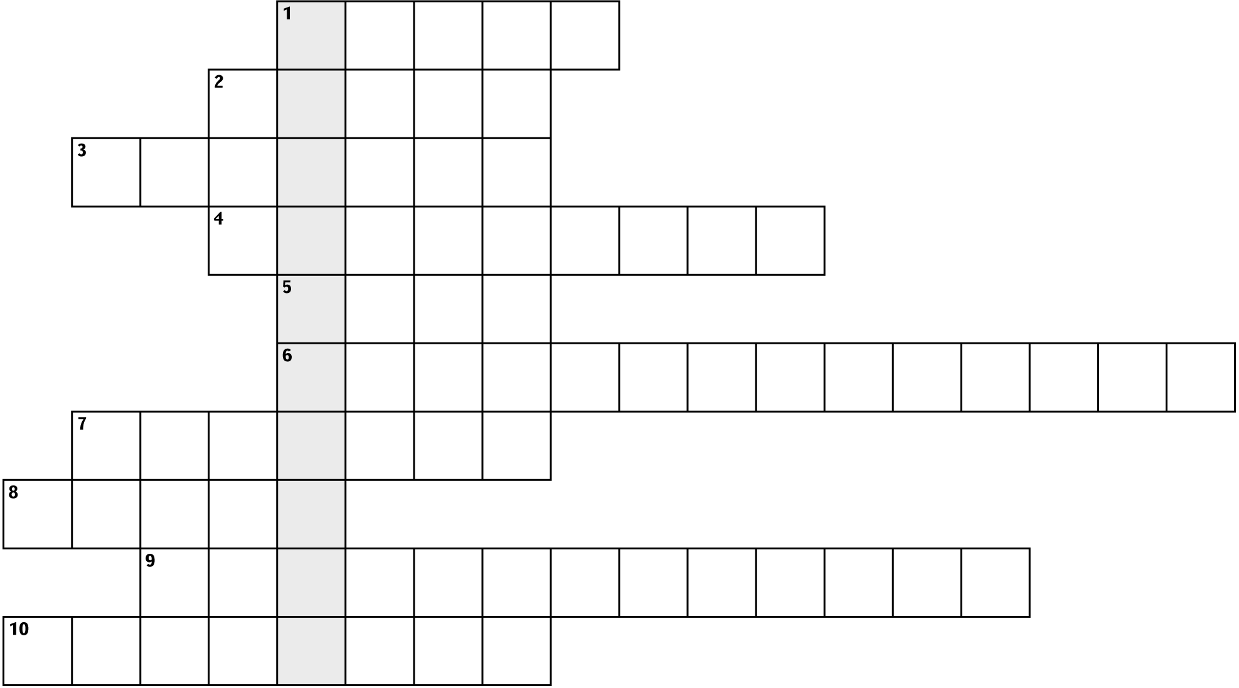

The word is ................................................... .

Task 6: Storyboard of Evolution of the Atmosphere
Draw a 6 panel storyboard to describe how the atmosphere of Earth has changed over time. Research this first using https://www.bbc.co.uk/bitesize/guides/zg4qfcw/revision/1 and books or other websites.
Each box should have a picture or diagram and a caption explaining what is shown.

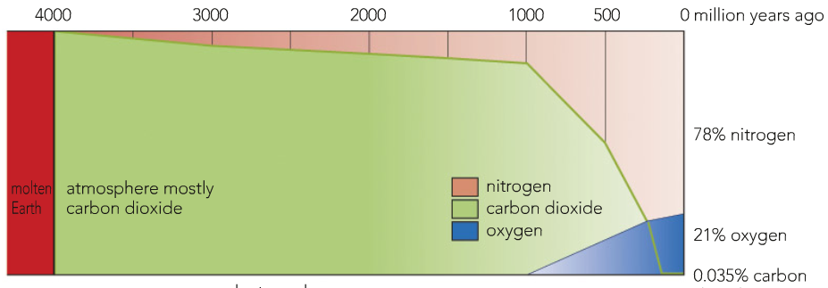
Task 7: Interpret the graph
Describe and explain the features of the graph below by completing the table.

Millions of years ago | Nitrogen % | Oxygen % | Carbon Dioxide %
4000
3000
2000
1000
500
0

Reasons for trends:
……………………………………………………………………………………………………………………………………………………………………………………………….
……………………………………………………………………………………………………………………………………………………………………………………………….
……………………………………………………………………………………………………………………………………………………………………………………………….
……………………………………………………………………………………………………………………………………………………………………………………………….
……………………………………………………………………………………………………………………………………………………………………………………………….
……………………………………………………………………………………………………………………………………………………………………………………………….
……………………………………………………………………………………………………………………………………………………………………………………………….

