C8.4 Types of chemical reactions

- Combustion is a reaction with oxygen in which energy is transferred to the surroundings as heat and light.
- Thermal decomposition is a reaction where a single reactant is broken down into simpler products by heating.
- Chemical changes can be described by a model where atoms and molecules in reactants rearrange to make the products and the total number of atoms is conserved.
- During a chemical reaction bonds are broken (requiring energy) and new bonds formed (releasing energy).
- If the energy released is greater than the energy required, the reaction is exothermic.
- If the reverse, it is endothermic.
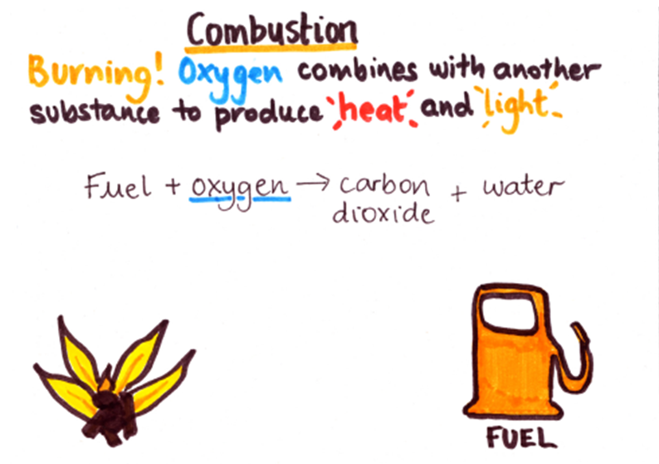 | 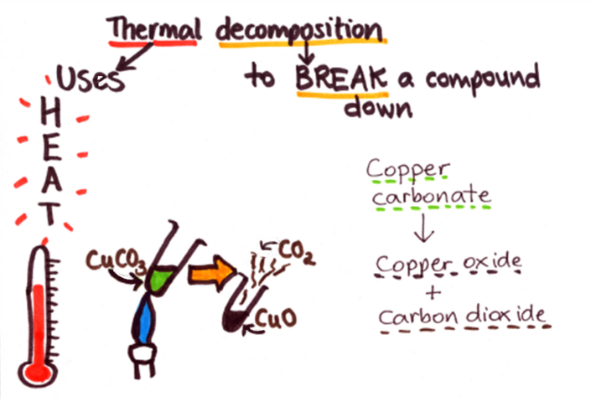
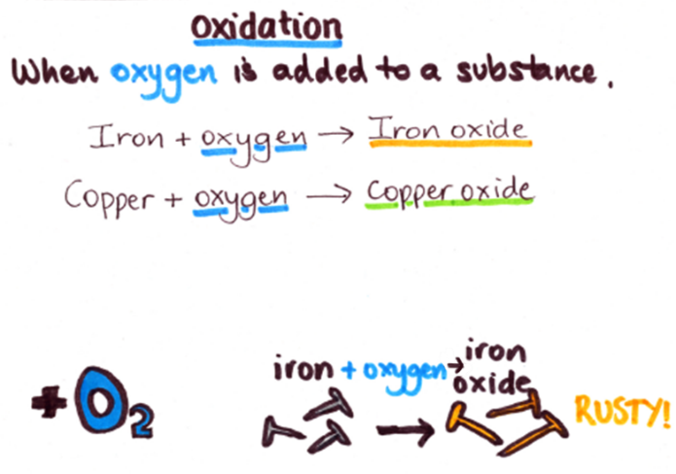 | 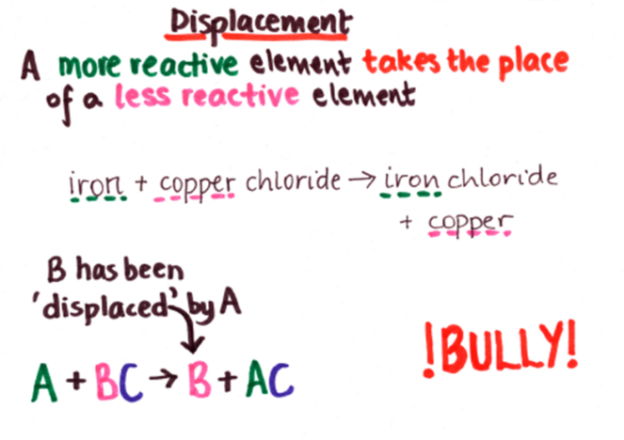
Keyword | Definition
Fuel | Stores energy in a chemical store which it can release as heat.
Chemical reaction | A change in which a new substance is formed.
Physical change | One that changes the physical properties of a substance, but no new substance is formed.
Reactants | Substances that react together, shown before the arrow in an equation.
Products | Substances formed in a chemical reaction, shown after the reaction arrow in an equation.
Conserved | When the quantity of something does not change after a process takes place.

Complete the columns, stating in each case whether a new substance is produced and whether the change is physical or chemical.
Change | Is a new substance produced ...? (Y/N) | Is the change physical or chemical …?
… when oxygen is mixed with a substance
… when a boiling kettle releases water vapour
… when you heat a substance and there is a colour change and a gas is given off
… when something combines with oxygen and gives out a lot of heat energy
… when sugar ferments to make alcohol
… when salt is added to water to make salt solution
… when an iodine block is heated to give off a vapour
… when a bonfire burns
… when glow sticks give out light
… when a battery powers a torch

For each equation below, decide what type of reaction it is and then complete the table.

Equation | Type of chemical reaction | Reason for choice
petrol + oxygen → carbon dioxide + water
sodium + magnesium chloride → magnesium + sodium chloride
magnesium carbonate → magnesium oxide + carbon dioxide
ethane + oxygen → carbon dioxide + water
magnesium + oxygen → magnesium oxide
lead + silver sulphate → lead sulphate + silver
zinc nitrate → zinc oxide + nitrogen dioxide + oxygen
kerosene + oxygen → carbon dioxide + water
sodium + oxygen → sodium oxide

This particle diagram shows the reaction between Methane and Oxygen
H
H
O
Methane + oxygen Carbon dioxide + water
H
H
C
H
H
Type of Atom | Number of atoms in the reactants
C
H
O
Type of Atom | Number of atoms in the products
C
H
O
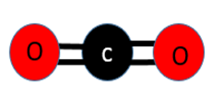
H
H
O
O
O
O
O
+
water
carbon dioxide
oxygen
+
methane

What do you notice?
Why?

For each equation below, decide what type of reaction it is and then try to complete the word equation.
a) Type of reaction:
wood + oxygen → _______________ _______________+ __________________
b) Type of reaction: ________________
____________ + ____________ → silver oxide
c) Type of reaction: ____________________
sodium carbonate (+ heat) → ________ __________ + _________ ___________
d) Type of reaction: _______________________
potassium + iron chloride → ________________ ______________ + iron
Complete these and draw particle diagrams:​

- Iron carbonate → ________ + ____________​
- Sodium carbonate → _______ + __________​
- Copper carbonate → _______ + __________​
- Zinc carbonate → _______ + __________​
Questions
- Combustion is a scientific word for:
  - Exploding
  - Burning
  - Evaporating
  - Getting hotter
- A fuel is:
  - A a substance formed from living organisms that lived a long time ago
  - a substance that explodes
  - a substance that contains hydrocarbons
  - a substance that transfers energy usefully, usually by heating.
- When hydrogen reacts with oxygen, the product is:
  - Water
  - Oxide
  - Carbon dioxide
  - Hydrogen
- Many pollutants are formed by the combustion of fossil fuels such as petrol and diesel. Two of these pollutants are carbon monoxide and carbon dioxide.
- a)
i)Name one non-metal oxide pollutant that is produced from the combustion of an impurity in fossil fuels.
ii) Name one non-metal oxide pollutant that is produced by the high temperatures inside a vehicle engine when it is burning fossil fuels.
b) Fossil fuel combustion can cause acid rain. Explain how.
c) Explain how carbon monoxide is formed in a car engine.
d) Explain how the amount of carbon monoxide released into the air from a car exhaust can be reduced.
e) Explain why carbon dioxide from fossil fuel combustion is a problem.
Task
Create an information poster about the types of reactions using the links bellow to help you.
- https://www.bbc.co.uk/bitesize/guides/zqd2mp3/revision/1
- https://www.youtube.com/watch?v=RV8wMapGvQk
- https://www.youtube.com/watch?v=cRnpKjHpFyg
- https://www.youtube.com/watch?v=BgM3e8YZxuc
- https://www.youtube.com/watch?v=5iowJs6MryI

