C4 Chemical Changes Pack for Year 10 – Electrolysis
Facts
Electrolysis (splitting up a substance using electricity):
- When an ionic compound is melted or dissolved in water, the ions are free to move around the liquid. This means they are able to conduct electricity. We call these electrolytes.
- Electrolysis requires:
  - 2 electrodes
  - An electrolyte (ionic or molten substance)
  - A power supply
- Electrolysis: When you pass an electric current through electrolytes, the ions move to the electrodes. Ions move towards oppositely charged electrodes. Positive ions move to the cathode (negative electrode) and negative ions move to the anode (positive electrode).
- When a simple molten ionic compound is electrolysed, the metal is produced at the cathode and the non-metal at the anode.
- Electrolysis is used to extract the metal from a molten compound. Large amounts of energy are needed to melt the compounds and to produce the electrical current.
- At the negative electrode, hydrogen is produced if the metal is more reactive than hydrogen.
- At the positive electrode, oxygen is produced unless the solution contains halide ions when the halogen is produced
- At the cathode, positively charged ions gain electrons and so reactions are reductions.
- At the anode, negatively charged ions lose electrons and so reactions are oxidations.

Task 1: Watch Free Science lessons (if you can) and do a mind map of the information

GCSE Science Chemistry (9-1): Introducing Electrolysis

GCSE Science Chemistry (9-1): Electrolysis of Aluminium oxide

GCSE Science Chemistry (9-1): Electrolysis of Aqueous Solutions 1

GCSE Science Chemistry (9-1): Electrolysis of Aqueous Solutions 2

GCSE Science Chemistry (9-1): Required Practical 3: Electrolysis

Task 2: Test yourself! Answer these quick fire questions.

- When do ionic compounds conduct electricity?
- Why do ionic compounds need to molten or dissolved to conduct?
- What happens to positive ions during electrolysis?
- What happens negative ions during electrolysis?
- If a metal chloride is being electrolysed what gas will be produced?
- If metal sulfate is being electrolysed what gas will be produced?
- How do you test for chlorine gas?
- How do you test for hydrogen gas?
- How do you test for oxygen gas?
- Balance this ……….Cl⁻ ………. → Cl₂
- Balance this Mg²⁺ ……………. → Mg

Task 3: Answer this examination question.
This question is about zinc. Figure 1 shows the electrolysis of molten zinc chloride.
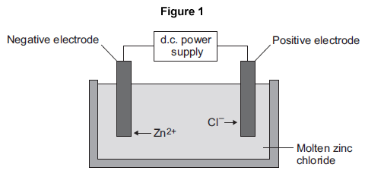
(a) Zinc chloride is an ionic substance. Complete the sentence.
When zinc chloride is molten, it will conduct .................................................. .(1)
(b) Zinc ions move towards the negative electrode where they gain electrons to produce zinc.
(i) Name the product formed at the positive electrode. .................................................................... (1)
(ii) Explain why zinc ions move towards the negative electrode. (2)

(iii) What type of reaction occurs when the zinc ions gain electrons? (1)

Task 4: Answer this examination question:
This question is about magnesium and magnesium chloride.
(a) Magnesium chloride contains magnesium ions (Mg²⁺) and chloride ions (Cl⁻). Describe, in terms of electrons, what happens when a magnesium atom reacts with chlorine atoms to produce magnesium chloride. (4)
(b) Magnesium chloride can be electrolysed. The diagram below shows two experiments for electrolysing magnesium chloride.
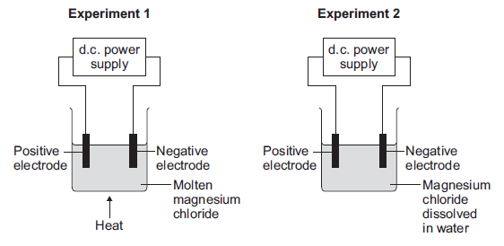
(i) Explain why magnesium chloride must be molten or dissolved in water to be electrolysed. (2)

(ii) Explain how magnesium is produced at the negative electrode in Experiment 1. (3)

(iii) In Experiment 2 a gas is produced at the negative electrode. Name the gas produced at the negative electrode. (1)
(iv) Suggest why magnesium is not produced at the negative electrode in Experiment 2. (1)
(v) Complete and balance the half equation for the reaction at the positive electrode.
.......... Cl⁻ → Cl₂ + .......... (1)

Task 5: This question is about the electrolysis of aluminium oxide.

