C4 Chemical Changes Pack for Year 10 - Acids and Alkalis
Facts
Reactions of acids:
- Acid + metal salt + hydrogen (sulphuric acid + magnesium magnesium sulphate + hydrogen)
- Acid + alkali/base salt + water (nitric acid + copper oxide copper nitrate + water)
- Acid +metal carbonate salt +water +carbon dioxide
- The salt produced depends on the acid used and the positive ions in the base, alkali or carbonate
- Acid + metal oxide/hydroxide/carbonate soluble salt. The solid is added to the acid until it doesn’t react any more. The excess solid is filtered to leave a solution of the salt.
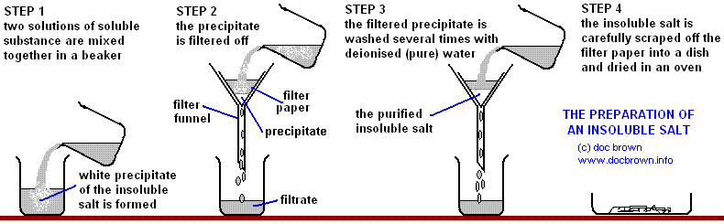
- An alkali is a soluble base
- A neutralisation reaction occurs when an acid is reacted with an alkali (e.g. soluble metal hydroxides)/ base (e.g. insoluble metal hydroxides and oxides)
- Neutralisation reaction: H⁺ (aq) +OH⁻ (aq) H₂O (l)
- Salt solutions can be crystallised by evaporation to produce solid salts.
- Acids dissociate to form hydrogen ions (H⁺) in aqueous solutions.
- Aqueous solutions of alkalis contain hydroxide ions (OH⁻)
- The pH scale is a measure of how acidic or alkaline a solution is. A solution with pH below 7 is acidic and a pH above 7 is alkaline.
- The pH of the solution can be measured using universal indicator paper or a pH probe.
- A strong acid (e.g. hydrochloric, nitric and sulphuric) is completely ionised in aqueous solution.
- A weak acid (e.g. ethanoic, citric and carbonic) is only partially ionised in aqueous solution.
- As the pH decreases by 1 unit, the hydrogen ion concentration of the solution increases by a factor of 10.

Task 1: Watch Free Science lessons (if you can) and do a mind map of the information

GCSE Science Chemistry (9-1) Acids and Alkalis

GCSE Science Chemistry (9-1) Acids reacting with Metals

GCSE Science Chemistry (9-1) Acids reacting with Metals 2

GCSE Science Chemistry (9-1) Three reactions of Acids

GCSE Science Chemistry (9-1) Required practical 1: Making Soluble Salts

GCSE Science Chemistry (9-1) Strong and Weak Acids

GCSE Science Chemistry (9-1 Triple) Required practical 2: Carrying out a Titration

GCSE Science Chemistry (9-1 Triple) Titration calculations 1

GCSE Science Chemistry (9-1 Triple) Titration calculations 2

Task 2: Test yourself! Answer these quick fire questions.

- What ion is responsible for acidity?
- What ion is responsible for alkalinity?
- Is pH 1 acid, alkali or neutral?
- Is pH 7 acid, alkali or neutral?
- Is pH 14 acid, alkali or neutral?
- Write down the neutralisation equation.
- Give an example of a strong acid.
- Give an example of a weak acid.
- What is a concentrated acid?
- What is a dilute acid?

Task 3: Complete the table below. The first one has been done for you.

Formula of salt | Name of salt | Original metal | Original acid
NaCl | Sodium chloride | Sodium | Hydrochloric acid
LiCl
CaSO₄
MgSO₄
KNO₃

Task 4: Write a word equation for the reactions between:
  - Aluminium and hydrochloric acid
  - Magnesium and hydrochloric acid
  - Calcium and nitric acid
  - Beryllium and sulphuric acid
  - Iron and sulphuric acid
Task 5: Write a word equation for a reaction which forms:
  - Aluminium sulphate
  - Calcium chloride
  - Barium nitrate
  - Rubidium chloride
Challenge: write symbol equations for every reaction in Q1 and Q2
Task 6: Complete these short answer questions.
- Sulphuric acid is a strong acid. Explain what this means.

- Which ions does sulphuric acid split up into?

- 2g of sulphuric acid is dissolved in water, and the pH is found to be 2. What mass of acid would be required for a pH of 1?

- Complete the table below, using the words “high,” “medium” or “low” to represent pH. The first one has been done for you.
 | Concentrated | Dilute
Strong acid | Low
Weak acid

- Write a word equation for the reaction between sulphuric acid and sodium hydroxide

- Write a symbol equation for this reaction

- Write an ionic equation for this reaction

- 10g of acid is dissolved in water, followed by another 10g. What happens to the pH?

- In terms of the number of H⁺ ions in solution, explain why a strong acid has a lower pH than a weak acid.
Task 7: For each of the reactions below, write:
  - A word equation

  - A balanced symbol equation (assume that all hydroxides are dissolved in water)
  - An ionic equation

Potassium hydroxide and hydrochloric acid

Magnesium hydroxide and hydrochloric acid

Sodium hydroxide and nitric acid

Sodium hydroxide and sulphuric acid

Iron (III) hydroxide and sulphuric acid

Task 8: Answer this examination question.

