C1 Atoms and the Periodic Table Pack for Year 9 Part 2
Facts

- Ionic compounds have regular structures (giant ionic lattices) in which there are strong electrostatic forces of attraction in all directions between oppositely charged ions.
- These compounds have high melting points and high boiling points because of the large amounts of energy needed to break the many strong bonds.
- When melted or dissolved in water, ionic compounds conduct electricity because the ions are free to move and so charge can flow.
- Substances that consist of small molecules are usually gases or liquids that have relatively low melting points and boiling points.
- These substances have only weak forces between the molecules (intermolecular forces). It is these intermolecular forces that are overcome, not the covalent bonds, when the substance melts or boils.
- The intermolecular forces increase with the size of the molecules, so larger molecules have higher melting and boiling points.
- These substances do not conduct electricity because the molecules do not have an overall electric charge.

- Polymers have very large molecules. The atoms in the polymer molecules are linked to other atoms by strong covalent bonds.
- The intermolecular forces between polymer molecules are relatively strong and so these substances are solids at room temperature.

- In diamond, each carbon atom forms four covalent bonds with other carbon atoms in a giant covalent structure, so diamond is very hard, has a very high melting point and does not conduct electricity.
- In graphite, each carbon atom forms three covalent bonds with three other carbon atoms, forming layers of hexagonal rings which have no covalent bonds between the layers.
- In graphite, one electron from each carbon atom is delocalised.

- Graphene is a single layer of graphite and has properties that make it useful in electronics and composites.
- Fullerenes are molecules of carbon atoms with hollow shapes. The structure of fullerenes is based on hexagonal rings of carbon atoms but they may also contain rings with five or seven carbon atoms.
- The first fullerene to be discovered was Buckminsterfullerene (C60) which has a spherical shape.
- Carbon nanotubes are cylindrical fullerenes with very high length to diameter ratios. Their properties make them useful for nanotechnology, electronics and materials.

Task 1: Watch Free Science lessons and do a mind map of the information of some of them.

GCSE Science Chemistry (9-1) Properties of small covalent molecules

GCSE Science Chemistry (9-1) Diamond and silicon dioxide

GCSE Science Chemistry (9-1) Graphite

GCSE Science Chemistry (9-1) Graphene and Fullerenes

GCSE Science Chemistry (9-1) Bonding in polymers
GCSE Science Chemistry (9-1 Triple) Nanoparticles
GCSE Science Chemistry (9-1 Triple) Limitations of Bonding Diagrams

Task 2: Test yourself! Answer these quick fire questions.

- Describe the structure of an ionic compound.
- Describe the properties of an ionic compound.
- Describe the structure of a simple covalent compound.
- Describe the properties of a simple covalent compound.
- Describe the structure of giant covalent compound.
- Describe the properties of a giant covalent compound.
- What is a monomer?
- What is a polymer?
- Describe the structure of a polymer.
- Which element is both diamond and graphite made from?
- Describe the bonding in diamond.
- Describe the difference between the bonding in diamonds and the bonding in graphite?
- What are the properties of graphite?
- What are the uses of graphene?
- What are the uses of fullerenes?
- Describe the structure of fullerenes.
- Describe the structure of carbon nanotubes.

Task 3: This part of the question is about graphene.
Choose the correct answer to complete each sentence.
(i) The bonds between the atoms in graphene are .............................................(1)
(ii) Graphene is made of .................................................... atoms. (1)
(iii) In graphene each atom bonds to ...................... other atoms. (1)

Task 4: This part of the question is about graphite.
Graphite is used in pencils. Explain why (2)

Graphite is a non-metal. Explain why graphite conducts electricity. (3)

Task 5: Read the passage and answer the questions.
Lightweight handlebars for bicycles are made from materials containing carbon nanotubes. Carbon nanotubes are lightweight but very strong.
(a) Complete each sentence.
(i) Carbon nanotubes are similar to graphite because each carbon atom is joined to ________ other carbon atoms.
(ii) The carbon atoms are joined by ______ bonds
(iii) Carbon nanotubes are very strong because the ________________ are hard to break

Task 6: Answer these questions about nanotubes:
An airplane contains many miles of electrical wiring made from copper. This adds to the mass of the airplane. It has been suggested that the electrical wiring made from copper could be replaced by lighter carbon nanotubes.
(i) What does the term ‘nano’ tell you about the carbon nanotubes? (1)
(ii) Like graphite, each carbon atom is joined to three other carbon atoms. Explain why the carbon nanotube can conduct electricity. (2)

Task 7: Compare the structures of nanotubes, fullerenes and graphene:
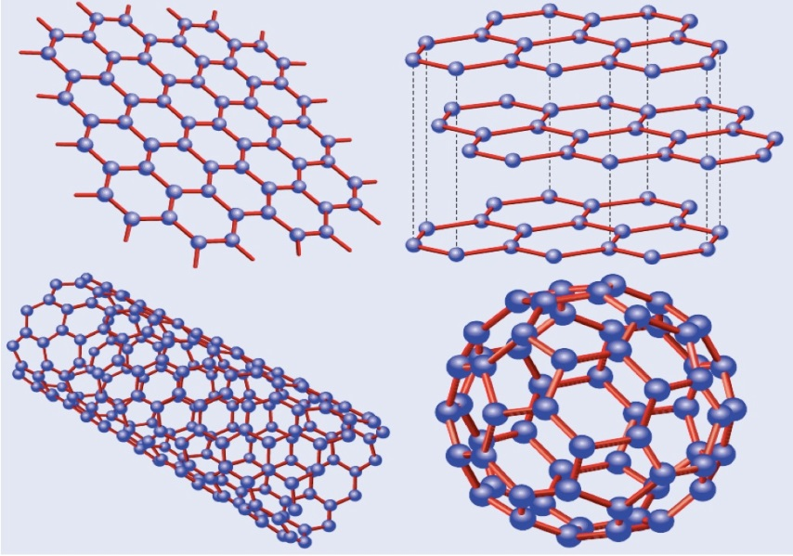
 | Graphene | Fullerene | Nanotube
Structure

Uses

Task 8: Answer these questions about polymers

- Polyethane is made of carbon and hydrogen only. Methane is also made of carbon and hydrogen only. Why does polyethane have a much higher melting point than methane?

- Ammonia (NH₃) is a simple molecular substance. Explain why it has a low melting and boiling point
Explain why ammonia cannot conduct electricity.

- What is the main difference between simple molecular substances and giant covalent substances?

- Polymers do not conduct electricity. Explain why not.

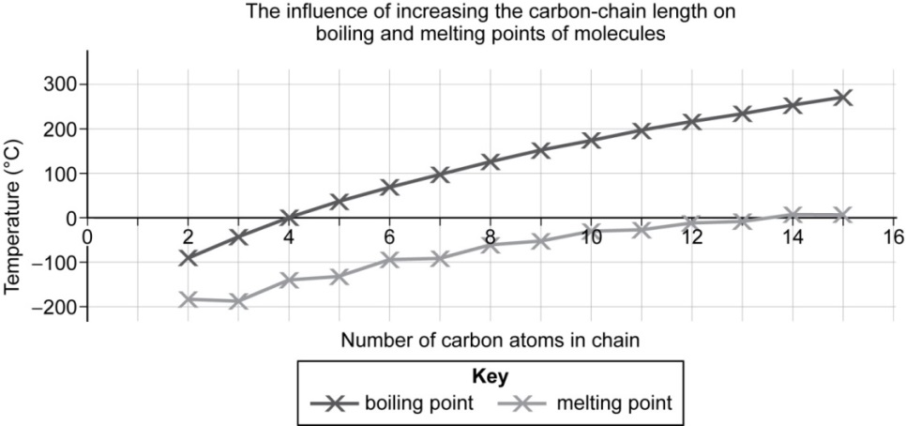
- Challenge: Look at the graph below

- Describe the pattern seen for the melting and boiling points.

- Explain these patterns using your knowledge of structure, bonding and forces.

Task 9: A student has a sample of two substances.
One is graphite and the other is sodium chloride.
- Other than appearance, how could the student identify which is which?

- In terms of charged particles, what is the difference in electrical conductivity between graphite and an ionic substance?

- How can you tell from the elements sodium chloride is made of that it will be ionic?

- Draw a dot and cross bonding diagram for sodium chloride

- Explain why sodium chloride has a high melting and boiling point

