C1 Atoms and the Periodic Table Pack for Year 9 Part 1
Facts

C1.1 Elements, Compounds and Mixtures
- Elements are made of one type of atom but compounds are made of more than one type of atom, bonded together.
- Mixtures are made from two or more elements or compounds, not chemically combined together.
- There are about 100 elements.
- Chemical reactions produce new substances but Physical processes do not produce new substances.
- Soluble means that something can dissolve and insoluble means something that will not dissolve.
- Undissolved solids can be separated from liquids by filtration.
- Dissolved solids can be separated from solutions by crystallisation.
- Liquids can be separated from solutions by simple distillation.
- Liquids can be separated from a mixture of liquids by fractional distillation.
- Mixtures of inks, or food colouring, can be separated by chromatography.

C1.1 Development of atomic structure
- Scientific model may be changed or replaced if new experimental evidence is discovered.
- Before electrons were discovered, people thought atoms were tiny spheres that could not be divided.
- When electrons were discovered, people thought of atoms were balls of positive charge with negative electrons in them and called this the plum-pudding model.
- The alpha particle scattering experiment showed the plum-pudding model was wrong and it was replaced by the nuclear model.
- Niels Bohr carried out calculations that predicted that electrons orbit the nucleus at particular distances. Experimental observations agreed with Bohr’s calculations. Later experiments led to the idea that the positive charge of any nucleus could be subdivided into a whole number of smaller particles, each particle having the same amount of positive charge.
- Experiments showed that the nucleus contained smaller particles which had a positive charge. These particles were called protons.
- James Chadwick carried out experiments that showed that the nucleus also contained particles called neutrons.

C1.1 Atomic structure
- The nucleus is made from protons and neutrons. Electrons orbit the nucleus.
- Protons and neutrons both have a relative mass of 1. Electrons have a very small relative mass.
- Protons have a charge of +1. Electrons have a charge of -1. Neutrons have charge of 0.
- The number of protons in an atom is its atomic number.
- Atoms of each element has a different number of protons
- Atoms have an equal number of protons and electrons so atoms have no overall electrical charge.
- The number of protons and neutrons in an atom added together is the mass number.
- The number of neutrons is equal to: Mass number - Atomic number.
- Isotopes are atoms with the same number of protons, but a different number of neutrons.
- Relative atomic mass is calculated using the abundance of each isotope of an element.
- Atoms are very small and have a radius of about 0.1 nm (1 x 10⁻¹⁰ m).
- The radius of a nucleus is less than 1/10 000 of that of the atom (about 1 x 10⁻¹⁴ m).
- The innermost shell of an atom can contain a maximum of 2 electrons. The other shells can contain up to 8 electrons. Atoms can gain or lose electrons in chemical reactions and will become charged.
- Atoms with an electrical charge are called ions.

Task 1: Watch Free Science lessons and do a mind map of the information of some of them.

GCSE Science Chemistry (9-1) Elements, Compounds and Mixtures.

GCSE Science Chemistry (9-1) Interpreting a chemical formula

GCSE Science Chemistry (9-1) Filtration and Crystallisation

GCSE Science Chemistry (9-1) Simple Distillation

GCSE Science Chemistry (9-1) Fractional Distillation

GCSE Science Chemistry (9-1) Chromatography

GCSE Science Chemistry (9-1) Alpha-Scattering Experiment

GCSE Science Chemistry (9-1) The Nuclear Model

GCSE Science Chemistry (9-1) Atomic Number and Mass Number

GCSE Science Chemistry (9-1) Relative Atomic Mass

GCSE Science Chemistry (9-1) Electron Energy Levels

Task 2: Test yourself! Answer these quick fire questions.

- What is a compound?
- What is a mixture?
- Give three ways of separating out mixtures
- What did Chadwick discover?
- What experiment did Rutherford do?
- What type of foil did Rutherford use?
- What did Rutherford fire at the foil?
- What model of the atom was Rutherford testing?
- What did Rutherford discover?
- What was the new model of the atom called?
- Where are electrons, protons and neutrons found?
- What charge do protons, neutrons and electrons have?
- What does the atomic number tell us?
- What does the mass number tell us?

Task 3: Answer these questions about atomic models.
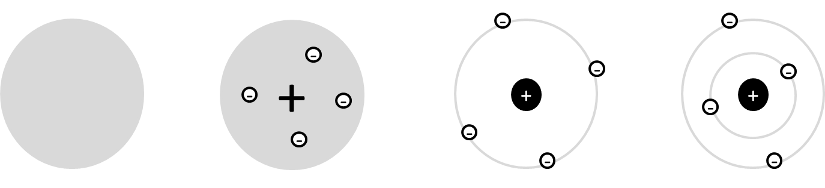

- Use the keywords and phrases to label the diagrams above. Some can be used more than once.
Nuclear model, negative charges studded in, negatively charged electrons, ball of spread out positive charge, hard sphere, positive nucleus, fixed energy level, electron shell model, protons and neutrons, empty space
- State two differences between Dalton’s model and the Plum Pudding model.

- State three differences between the Plum Pudding model and the nuclear model.

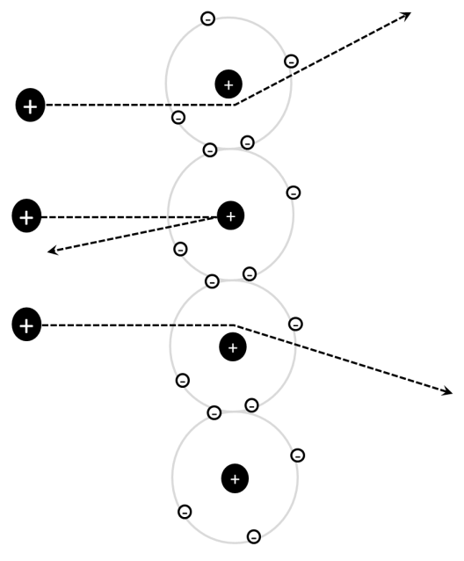
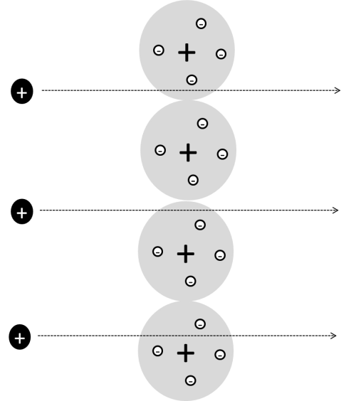

- Label the diagrams with the labels below. Some labels should be used more than once.
nucleus with dense positive charge, negative electrons orbiting nucleus, negative electrons studded in, alpha particles, expected to travel straight through, spread out positive charge, deflected path, then layer of atoms
- Describe the plum pudding model of the atom.

- Outline the Rutherford Scattering experiment and explain what conclusion could be drawn from the Rutherford Scattering experiment.

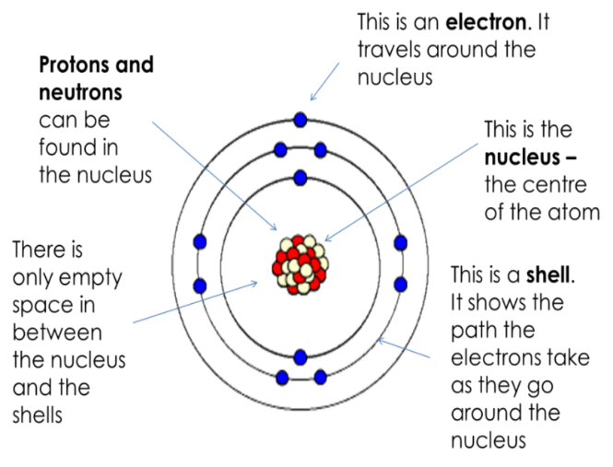
Task 4: Below is a diagram of an atom. Fill in the labels.
- What is smaller, an atom or a proton?
- What is between the electrons?
- What is the charge on an electron?
- A student draws an atom and labels the centre “nucleus with electrons.” Explain why the student is wrong.
- What label should the student use?
- What is the charge on a proton?

Task 5: Fill in the blanks.
There are about 100 different types of a_____. They differ in their numbers of p_______, n______ and e______. If a s_________ is made of one type of atom, it is called an e__________. The different atoms and the name of the elements they make up are found in the p_______ t______ of e______ and are represented by a symbol (e.g. Na = _____________).
If an atom has 7 protons, what would its relative mass be?
Task 6: Complete the table:
Element | Symbol | Atomic number | Neutrons | Mass number
Hydrogen | H | 1 | 0 | 1
Nitrogen |  | 7 | 7 | 14
Carbon | C | 6
 | Fe | 26
Gold |  |  | 118 | 197
 | Ge |  | 41
Tellurium |  |  |  | 128
Copper |  | 29 | 35 | 64
 | Co
 |  |  | 161

Task 7: Answer this synoptic question
In a reaction, copper sulphate and sodium hydroxide react together to form copper hydroxide and sodium sulphate.
- Write a word equation for this reaction.

- What are the reactants and what are the products?

- The formula for copper sulphate is CuSO₄. Which atoms are present in it?

- Explain why copper sulphate is a compound.

- Sodium hydroxide is NaOH, copper hydroxide is Cu(OH)₂ and sodium sulphate is Na₂SO₄. Write a balanced symbol equation for this reaction.

