4.2 Exchange surfaces
Key facts

- Feathery projection (gills fish) increase surface area, thin walls for diffusion, water pumped over the gills.
- Tracheae (insects) have spiracles that can close, are moist, are branched to increase surface area, are short.
- The lungs are in the upper part of the body (thorax). They are protected by the ribcage and separated from the lower part of the body (abdomen) by the diaphragm.
- The breathing system takes air into and out of the body so that oxygen from the air can diffuse into the bloodstream and carbon dioxide can diffuse out of the bloodstream into the air. This happens due to the concentration gradient.
- The movement of air into and out of the lungs is known as ventilation.
- To make air move into the lungs:
    - the ribcage moves out and up
    - the diaphragm flattens.
- These changes are reversed to make air move out of the lungs

- Lungs are made up of millions of tiny air sacs called alveoli. These are wrapped in a fine mesh of capillaries
- O2 and CO2 move between blood and air via Diffusion
- Concentration gradient is maintained by blood moving oxygenated red blood cells
away quickly

- O2 is carried in haemoglobin inside red blood cells.
- Carbon dioxide is carried in Plasma
- The alveoli are small sacs which increase the surface area available for gas exchange. To allow this to happen they have:
- thin, moist cells with permeable membranes;
-a capillary network of blood.

Task 1: Task 1: Watch free Science lessons (if you can) and do a mind map of the information.

GCSE Biology 9-1 Gas exchange in the lungs

Task 2: Copy the diagram of the gas exchange system and label it
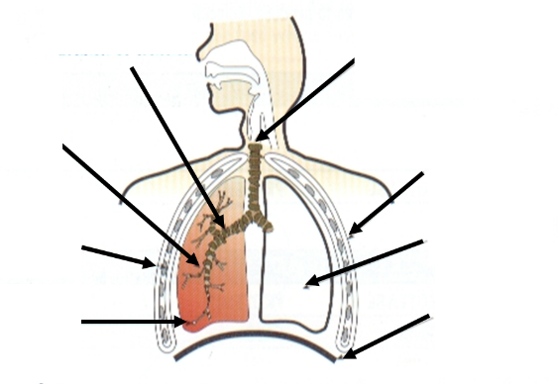

Task 3: Complete the following table by writing correct part of the lung
Part of body | Function
 | Also called the ‘wind pipe’
 | Stops the trachea from collapsing when you inhale
 | Protect the lungs from damage
 | The large muscle controls breathing
 | These fine passages carry air into alveoli
 | Two large air filled bags in the chest
 | These muscles lie in between the ribs and help in breathing
 | The trachea splits into two here
 | Allows us to talk
 | Where gases enter and leave the blood stream
 | Pumps blood to and from the lungs

Task 4: Describe how air is moved into and out of your lungs by completing the following table
 | Intercostal Muscles and Ribs | Diaphragm | Volume inside the chest | Pressure inside the Chest | Direction of Air
Inhalation

Exhalation

Task 5: Copy and complete the following fill in the blanks to describe the adaptations of the alveoli
Your lungs are specially made adapted to make gas exchange more efficient. They are made up of cluster of a…………………….that provide a very large s…………………………. a……………………………. This is important for achieving most effective d………………………………of oxygen and carbon dioxide. The alveoli also have a rich supply of b…………………………… C…………………………………….. This maintains a concentration gradient in both directions. The blood coming to the lungs is always relatively low in o……………………………….and high in carbon dioxide compared to inhaled air. As a result, gas exchange takes place down the s…………………………..concentration gradients possible. This makes the exchange r……………………………… and effective. The layer of cells between the air in the lungs and the blood in the capillaries is also very t………………………..(only one cell wide). This allows diffusion to take place over the s……………………………………..possible distance. If all of the alveoli in your lungs were spread out flat, they would have a surface area equivalent to ……………………………….table tennis tables.

Task 6: Extended answer Questions
- Explain how the villi and the alveoli are adapted to absorb molecules into the bloodstream.
- What are the similarities and differences between human lungs and Gills in the fishes

4.2 Cardiovascular System
Key facts – section 1
- Things that refer to the heart are prefixed cardio
- Things that refer to the lungs are prefixed pulmonary
- The heart has four chambers, 2 atria (top of the heart) and2 ventricles (bottom of the heart)
- Blood vessels leading into the heart are called veins
- Blood vessels leading out of the heart are called arteries
- Heart muscle is supplied directly by cardiac arteries
- Humans have a double circulatory system, where blood goes through the heart twice for every circuit around the body.
- Heart and blood vessels together are called the Cardiovascular System

Task 1: Task 1: Watch free Science lessons (if you can) and do a mind map of the information
- GCSE Biology 9-1 Heart and the Circulation

Task 2: Copy following diagram of Human Heart and add following labels

Task 3: Answer following questions in full sentences
- What are the two upper chambers of the heart called?
- What are the two lower chambers of the heart called?
- Where does the right side of the heart pump blood to?
- Where does the left side of the heart pumps blood to?
- What stops the blood from flowing wrong way?
- What happens to the heart rate when a person exercises? Why?
- Explain what would happen if a coronary artery is blocked?
- The left half of the heart has a thicker wall than the right side of the heart. Suggest a reason for this
Section 2: Cardiac Cycle Task 1: Revise structure of Heart
Copy and Complete following summary using words given below :
Atrium beats one rate two valves Ventricles
The heart is …………halves. The upper space on each side is called an ……The spaces beneath are called the ventricles. Blood flows through the heart in …….direction. The movement of blood is helped by ………….which stops the blood going in the wrong direction. The heart …………about 70 times each minute. This is called heart beat ………….
Key Facts Cardiac Cycle
- Blood arrives in the right atrium from the body via the vena cava.
- It is deoxygenated and at low pressure.
- It is pumped by the right ventricle to the lungs via the pulmonaryartery (medium pressure), where it picks up O2
- It returns to the heart into the left atrium via the pulmonary vein.
- It is pumped to the rest of the body from the left ventricle by the aorta.
- It is now oxygenated and at high pressure.

Task 2: Watch free Science lessons (if you can) and do a mind map of the information
- GCSE Biology 9-1 Heart and the Circulation ( at least 3 times)

Task 3: Rewrite following sentences in the correct order to describe a cardiac cycle. First one has been done for you.
- Deoxygenated blood arrives at the heart through Vena Cava.
- Left Atrium contracts
- Blood fills the right Atrium
- Blood leaves the heart through pulmonary artery
- Blood is oxygenated in the lungs
- Blood leaves the heart through the Aorta
- Right Ventricles contract
- Oxygenated blood travels along the pulmonary veins
- Blood is forced into left ventricle
- Blood gives up oxygen in the capillary beds
- Blood is forced into right ventricle
- Blood is prevented to flow back into the tight atrium by valve
- The left ventricle contracts
- Oxygenated blood passes around the body in circulation
- Blood fills the left atrium
- Blood is prevented to flow back into the left atrium by valve

Extended Questions:
- What is the difference between Single Circulation and Double Circulation?
- What is the advantage of a Double Circulation?
- Where is pacemaker located?
- What is the function of the pacemaker?
- What symptoms a person will get if pacemaker is not working correctly? Give reasons

